Game Show: 45 min/1 hr Show
PRODUCTION RIDER
Asterisk (*) denotes that detail is suggested but not required. Please note: Each detail is requested to provide maximum entertainment experience for the client and guests. If unable to provide any of these, this may detract from entertainment experience. All other details are mandatory.
STAGING & SPACE REQUIREMENTS
Performance space minimum: 3m (d) x 6m (w) minimum
* Elevated stage
Requires skirted table(s) to be provided for podiums – Silver Package ONLY
A/V REQUIREMENTS
Power to tech area + power to stage
2x 250w (minimum) speakers
2 x XLR for GS laptop & wireless headset mic - (Mic provided)
*Additional mic for host (Mic can be provided)
Small table for sound technician
Sound desk/inputs with “line in”; 1 x line in input for laptop audio, 1 x line in input for mic (Mini mixer can be provided)
- Top quality, clear sounding solo balanced Bose L1 with “Spacial Dispersion” speaker can be added for an additional $200 hire. Information on speaker below:
http://www.bose.com/controller?url=/shop_online/speakers/portable_amplification_systems/l1_model2/l1_model2_doublebass_pkg.jsp
LIGHTING
* 1-2 x follow spot on host (For larger stages)
* Spot operators
*White wash
Dimmed house lighting
- Lighting package HIGHLY recommended and most popular option. Adds real LIVE Game Show feel. $250 additional hire. For images or more information, please ask agent. See image below for example:

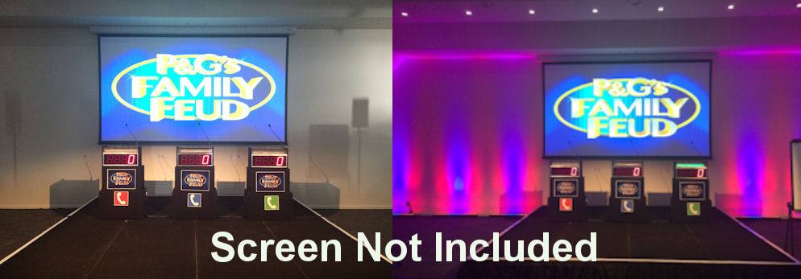
SEATING
Seats or tables should be as close to the stage as possible, with no gap separating the audience from the show. Any gaps such as a dance floor will take away from the performance. Stage should not be separated by audience and VIP guests or bridal party; All guests must be facing stage. A walkway down the middle is required, if stadium seating. There should be no guests sitting directly to the right or left side of stage. All seating should be in front with clear view of stage and screen(s).

QUESTIONS
The hour long Game Show can include up to 16 company or theme specific questions. It is necessary to get these questions sent to the agent as soon as possible or within 2 weeks prior of performance date so that they may be implemented.
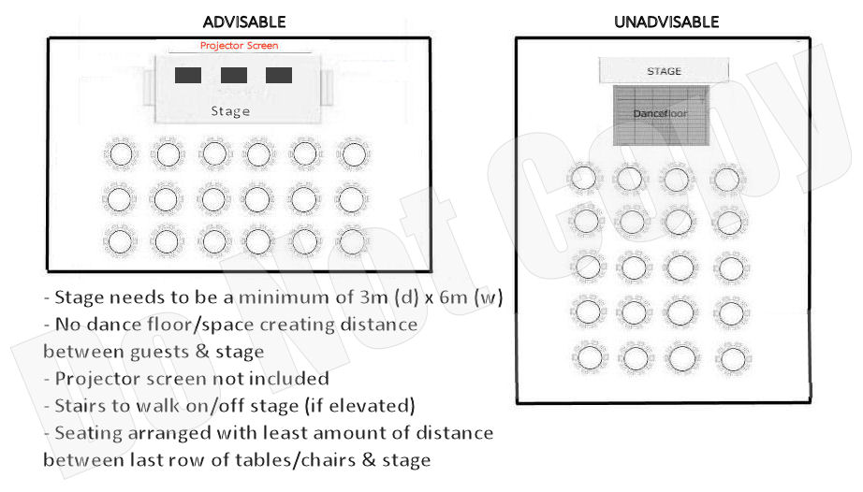
TIMING
Setup time is minimum 75 mins prior to performance. Client is to arrange with venue accordingly and communicate prior to event date. Performance must not take place during meals or meal service, not negotiable.
Please follow receipt of this Production Rider with venue layout or floor plan and confirm compliance.
If you have any further questions, please don't hesitate to ask!
Many thanks,
AE Team
These conditions are in place for your benefit, and the benefit of your guests and their entertainment experience. Please sign and return this form asap acknowledging that you understand and agree to the terms and conditions that have been requested.
Client signature: ____________________Date:__/__/____

