Host Rules & Guidelines
- Technician must be prompted by host with a ‘yes’ or ‘correct’ and ‘no’ or ‘incorrect’ for each question to apply score. (DO NOT say yes or no if you wish for them to elaborate on the answer or to try again.)
- Once a team buzzes in, the other teams are automatically locked out. If a team answers the question wrong and you signal ‘no’ to the technician, this question is then skipped. Be prepared to reveal the correct answer once indicated as ‘incorrect’ and then move on to the next question. (Reason: buzzer reset delay may cause inaccurate judgment of the first team to buzz in after question is answered incorrectly by opposing team)
- Do not under any circumstances, blame the system or technician for rules or guidelines that are not followed by host.
- Keep track of scoring if it is to be adjusted during game for any reason; This takes the technician a few seconds to adjust, so question must wait until process is finished or it cancels out the adjustment.
- If a team buzzes in out of turn or on accident, please move on by instructing technician to ‘PLAY ON’.
- If audience members are heard answering the questions loudly so that contestants can hear, do instruct them to resist doing this, as it is cheating, that the question will have to be skipped and move onto the next question.
- DO NOT humour guests if they question a call you (the Quiz Master) have made. Maintain control, don’t waste time, and most importantly, keep the ball rolling and the game in play.
- If you are ever unsure of whether or not a question is ‘correct’ (contestant did not answer in full or company question answer is unlike what they have given you, etc..) turn & motion to the audience for a ‘thumbs up’/’thumbs down’ ruling.
- If a famous musical sound clip question is answered correctly, you may offer up an additional 50 point BONUS to the team, if they are to then perform the dance from this said clip. (e.g. – Michael Jackson song/dance, MC Hammer song/dance, ‘walk like an Egyptian’ song/dance, ..) Once you suggest this to the team, the tech will then play the musical clip again. This is a time where you can use the audience ‘ruling’ on whether or not the team wins the points for the dance.
Before the game begins it is wise to introduce each team & ask them test their buzzers and microphones. Point out the different buzz-in sounds and the individual lighting on the podiums.

Explanation of the Rules (direct to audience): “(Personal intro into..) 3 teams, a mix of questions, .. I will read the question aloud and the teams will wait to hear the entire question before buzzing in to answer. If a team buzzes in BEFORE the answer is stated in full, the team must answer to the best of their ability and then we will move on to the next question. Once answered, I will then tell the team if they are correct or incorrect and the technician will provide accurate scoring.
The team that buzzes in the fastest, gets one chance to answer the question correctly. If they get the question wrong, (IMPORTANT) we will move onto the next question. The other teams will not get a chance to answer this same question.
If a team answers the question correctly, they are awarded ___ points. If they answer the question incorrectly, they are deducted ___ points. (If there are bonus point options for company specific questions, etc.. please explain this here)
You will notice there are images located on the front of your podiums. These symbolise your 1-time ‘phone-a-friend’ option. This is where you are able to ask the audience members to assist you in answering the question.
We will have 3x15 minute preliminary rounds, changing teams at the end of every round. (Explain how contestants are chosen; preselected or volunteers)
The winners of those 3 rounds will compete in the championship round to win (title/prize/award). Now, if there are no questions let’s play this year’s (company name/event title) GAME SHOW!!!”

Once each round ends: After Final Question, do a score check to show which team has won. Then prompt technician openly to “reset the scores” and then go into calling up the next 9 contestants.
Phone a Friend Option: When teams are unsure of the answer to a question be sure to remind them of their ‘phone a friend’ (audience member) option. Do this when you can so that all teams have the chance to use this and involve the audience.
Comical Challenges: Comical challenges will involve either the contestants or the audience members. Be sure to explain in detail the game and how it is played and scored.
Games –
*Comical Challenges should equal bonus points of 100, if game is going by 50 point scale.
NOTE: Tech will play music after host signals for game to start (“On yours marks, get set, go!”)
- Golf Game – Each team chooses one person to represent their team (Either one of the team members OR an audience member, if instructed by client prior to event to involve the most people). The person is to attempt to putt one of the golf balls into the hole without it coming out. One attempt is all each of them get. Each team gets a chance to win the points.

- Balloon Game – 3 people involved per team. Again based on client preference (contestants or audience members). 1 of the 3 people is the tree; the other 2 are the decorators. The song will start on the host’s word and the 2 decorators will blow up and TIE OFF as many balloons they can attaching them to the ‘tree’. The person representing the tree may not blow up balloons, they may only find ways to attach the balloons. (Note: Balloons MUST be tied off, but they do not have to be completely blown up. You use the word ‘attach’ and that can mean anything from holding the balloons in their hands, to sticking them up their shirt. You will not reveal this rule, you will let them figure it out for themselves as part of the game. Tell them to ‘be creative’). The team with the most balloons on the tree after 1 minute wins. The others do not receive any points.

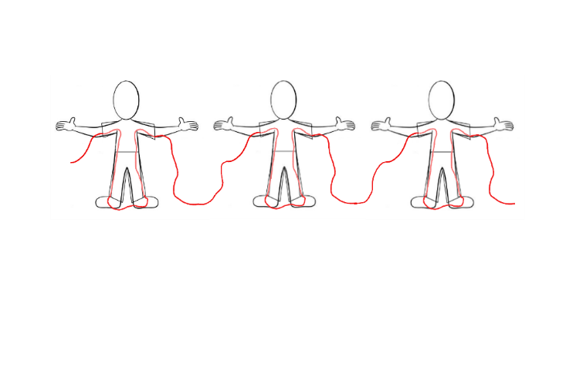
- Rope Game – 3 people involved per team. Again based on client preference (contestants or audience members). A rope is given to each team. Standing side by side, the teams have to string the rope through their shirt sleeve, down the pant (or skirt) leg, up the other pant (or skirt) leg, out the opposite shirt sleeve. It then has to rope the same way through the other 2 people. The first to finish roping through all 3 people with the same rope, wins. The others do not receive any points.

- Tennis Ball Game – 3 people involved per team. Once the host signals to start, the team that passes the ball from the first to the last person (with one person in between) up and back 3 times, wins the challenge. The catch is that they cannot touch the ball with their hands. They may only use the space between their chin and their neck. You may use members form the audience to keep track of the teams and to yell out which one completes the challenge first.

Common Jokes used:

